Allentown Presbyterian Church
CHILD AND YOUTH PROTECTION POLICY
Version 3.0
Objective
This policy is implemented to provide guidance and to describe the procedures and processes by which the Allentown Presbyterian Church endeavors:
(1) to protect the children and youth entrusted to its care from abuse (see Definitions), and,
(2) to protect those responsible for providing care and supervision to the children and youth of the Church by minimizing the occurrence of situations that could result in allegations of abuse.
This policy will assist the Church in fulfilling the mandate of the gospels to be in ministry with children, and to make a difference in their lives.

Background/Context
The Allentown Presbyterian Church (“the Church,” hereafter) is a church that is “growing in Christ.” This growth is evident in the increased attendance in Sunday worship services, and the increased number of children in the nursery, KinderWorship, Sunday School, Little Tree Preschool, and childrens’ and youth programs, special events, and retreats.
To respond and minister to these children and youth, we call upon the generous giving of time and energy from not only the paid full- and part-time staff of the Church, but also from the many volunteers upon whom the Church depends for successful implementation of Church-sponsored programs, ministries, and events. This policy has been developed to ensure the protection of children and youth of the Church as well as the adults entrusted with their care.
As we minister to these children, the Church is entrusted with their safety and well-being. The safety and well-being of all children entrusted to the Church’s care is of paramount importance and it is the intent of the Church to provide a safe and nurturing environment for all participants in Church-sponsored programs aligned with the teaching of the gospels.
It is the intent of this Church to protect all of God’s children from harm while they are within the Church’s care. Abusive behavior directed towards children will not be tolerated by the Church. It is also the intent of the Church to protect the persons entrusted with the care of children from situations that may place them at risk for unwarranted allegations of abuse. It is for these reasons that this policy is implemented.
The first step to the protection of our children, youth, and volunteers, is preventing situations within which problems could potentially develop. Through adherence to this policy, fostering congregational and volunteer awareness, and staff and volunteer training, we strive to protect the children entrusted to the Church’s care as well as those entrusted to provide that care.
This policy applies to all persons charged with the responsibility of caring for or supervising children or youth within the Church, the Church campus, or any Church-sponsored program, ministry, or event when that responsibility is executed on behalf of the Church or when that responsibility is executed in accordance with a designated Church-approved or sanctioned role.

Preparers
Maureen Harshman, Director of Children and Family Ministries
Jill Kurzeja, Director of Little Tree Preschool
Cathy Farley, Elder
Bruce Watt, Elder

Approval
Approved by Session on 18-Aug-2009 as documented in Session Meeting Minutes for Stated Meeting of Session on 18-Aug-2009.
Procedure
SECTION 1 – REQUIREMENTS OF NEW HIRES
Note: This section applies to persons who have applied for a paid, full- or part-time staff position within the Church and have accepted an offer of employment per the procedures and requirements of the Employment Policy. This section does not apply to persons volunteering for Church-sponsored programs, ministries, or events. (See sections 2 and 3 for volunteers.) Employees of Little Tree Preschool are not bound to Section 1 as they conform specifically to similar NJ statutes as dictated by law.
Responsibility | Procedure
Personnel Committee Representative or Program Director | - Prohibit any new hire from supervising or caring for children or youth independently until the requirements of Section 1 of this policy have been satisfied.  Note: New hires may assist in supervising or caring for children as long as they are supervised by a fully-qualified (see Definitions) staff member or “Regularly Serving Volunteer” (RSV) who has satisfied all requirements relevant to them as documented in this policy.  Note: Generally speaking, the Church will follow the “5-years-older rule” (see Definitions) when hiring persons who will be responsible for the care or supervision of children or youth.
New Hire | - Submit to a criminal background check, conducted by the NJ Division of State Police, before then end of the first calendar month of your start date.  Note: Every effort should be made to conduct the background check prior to your start date.
 | - Do not independently supervise or care (see step 1 above) for children until you have satisfied all of the requirements stated in Section 1 of this policy.
Program Director | - Ensure training on this Child and Youth Protection Policy is delivered to the new hire.
Program Director and New Hire | - Sign and date the Child and Youth Protection Policy Training and Acknowledgement Form (see Attachment 1 for an example).
New Hire | - Read, sign, and date the Participation Covenant Statement Form (see Attachment 2 for an example).
Personnel Committee Representative | - File the completed Child and Youth Protection Policy Training and Acknowledgement Form and the Participation Covenant Statement Form in the new hire’s personnel file.
 | - Communicate results of criminal background checks to the Program Director upon receipt.
 | - In the case results of the background check are such that employment cannot be continued, terminate employment of the new hire. Notify the applicable Program Director of the termination.
 | - Consider background check documentation as confidential, and file it in the personnel file for the new hire in a secure location.
Program Director | - Allow a new hire to independently supervise or care for children and youth (as needed) only after:  - satisfactory completion of a criminal background check,  - documented training on this Child and Youth Protection Policy has taken place, and  - new hire has read and signed a Participation Covenant Statement Form.
Employees | - Follow Section 4 when caring for or supervising children or youth.
Personnel Committee or Program Director | - Ensure fingerprinting/criminal background checks are repeated at 5-year intervals on an ongoing basis for each employee.
 | - Ensure that refresher training on this policy is provided to all staff on an annual basis or when significant procedural changes are made to this policy.

SECTION 2 – PROCEDURE FOR APPOINTING REGULARLY SERVING VOLUNTEERS (RSVs)
Note: This section of the Child and Youth Protection Policy applies only to volunteers (unpaid persons) who will be supervising or caring for children and youth on behalf of the Church or on behalf of Church-sponsored programs, ministries, or events in a regularly serving capacity. This section does not apply to persons hired as full- or part-time employees of the Church. (See section 1 for hired, paid staff.)
Note: All RSVs must be a member of the Church, an active participant in the Church, or be known to an officer, staff member, or member of the congregation for at least 6 months prior to being placed in a position of supervising or caring for children.
Responsibility | Procedure
Program/Ministry Director | - Prior to placing an RSV in a capacity to regularly care for or supervise children or youth, require that the person submit a fully completed Volunteer Application Form (see Attachment 3 for an example).  Note: Generally speaking, the Church will follow the “5-years-older rule” (see Definitions) when appointing RSVs who will be responsible for the care or supervision of children or youth.
- Make applicant aware that they must undergo (submit to) a criminal background check before the end of the first calendar month of their start date, and that their ongoing participation is contingent upon a satisfactory outcome from the background check.
Note: It is recommended that background check be completed prior to the volunteer’s start date.
 | - Evaluate the Volunteer Application Form in its entirety, and decide whether or not to place the person in a regularly serving capacity. Document your approval or rejection of the application on the form.
 | - File the Volunteer Application Form in secure, centralized location.
 | - Prohibit any new RSV from independently supervising or caring for children or youth until the requirements of Section 2 of this policy have been satisfied..
RSV | - Submit to a criminal background check, conducted by the NJ Division of State Police, before the end of the first calendar month of your start date.
- Do not independently supervise or care for children until:
- Results of the background check have been received and deemed satisfactory by a Personnel Committee representative or the Program, Ministry, or event Director,
- Training on this policy has been completed by you and that training has been documented (see Attachment 1 for an example), and
- You have agreed to and signed the Participation Covenant Statement Form (see Attachment 2 for an example).
- Session has approved your service in the care or supervision of children or youth.
Program/Ministry Director | - Deliver training on this Child and Youth Protection Policy.
Program/Ministry Director and RSV | - Sign and date the Child and Youth Protection Policy Training and Acknowledgement Form (see Attachment 1 for an example).
RSV | - Read, sign, and date the Participation Covenant Statement Form (see Attachment 2 for an example).
Program/Ministry Director | - Maintain the completed Child and Youth Protection Policy Training and Acknowledgement Form and the Participation Covenant Statement Form in a secure, centralized location.
 | - Deliver any other relevant training to the new RSV, based on their job responsibilities.
Personnel Committee | - Communicate satisfactory results of criminal background checks to the program, ministry, or event director upon receipt.
 | - In the case results of the background check are such that the RSV cannot continue in a capacity to supervise or care for children or youth, terminate the arrangement immediately. File relevant documentation in a secure, centralized location. Notify the applicable Program Director of the termination.
Session | - Approve all appointments of RSVs as needed, and document such approvals in the meeting minutes of the Meeting of Session during which those approvals were made.  Note: Session, based on their judgment, may exempt any RSV from any particular procedural requirements stated herein by their approval.
Program/Ministry Director | - Allow a new RSV to independently supervise or care for children and youth (as needed) only after:  - satisfactory completion of a criminal background check,  - documented training on this Child and Youth Protection Policy has taken place, and  - the RSV has read and signed a Participation Covenant Statement Form.  - Session has approved their service in the care or supervision of children or youth.
RSV | - Follow Section 4 when caring for or supervising children or youth.
Personnel Committee or Program Director | - Repeat, as necessary, criminal background checks at 5-year intervals.
 | - Ensure that refresher training on this policy is provided to all RSVs on an annual basis or when significant procedural changes are made to this policy.

SECTION 3 – PROCEDURE FOR APPOINTING OCCASIONALLY SERVING VOLUNTEERS (OSVs)
Note: This section of the Child and Youth Protection Policy applies only to unpaid persons who will be assisting in the supervision or care for children and youth on behalf of the Church or Church-sponsored programs, ministries, or events on an occasional, or intermittent basis, based upon fluctuating needs of the Church’s program, ministries, or events. This section also applies to youth who may be placed in a role of assisting in the supervision or care of children.
Note: All OSVs must be a member of the Church, an active participant in the Church, or be known to an officer or staff member, or member of the congregation for at least 6 months prior to being placed in a position of supervising or caring for children.
Responsibility | Procedure
Program Director | - Prior to the serving, instruct the OSV of their responsibilities for the particular event or activity for which they are volunteering.
 | - Ensure that one or more fully-qualified staff members or RSVs are responsible for oversight of the OSVs at all times for the event or activity.
- Instruct the OSV that:
- they are not to be alone with any single child or youth for the duration of the event or activity,
- they must limit activities to “public areas” (see Definitions)
- they must report any incidents or inappropriate behavior to you, the Program Director , or to another fully qualified person, and
- their role is to assist in the supervision or care of children or youth, under the direction of fully qualified staff members or regularly-serving volunteers.
Note: Situations that may require, for example, an OSV to drive a group of children or youth to a mission or group activity would not consistitute a violation of the “public area” requirement (see second bullet above).

SECTION 4 – CARING FOR AND SUPERVISING CHILDREN AND YOUTH
Note: This section applies to all staff and RSVs.
Responsibility | Procedure
All Staff and RSVs | - Whenever possible, abide by the “Never Alone Rule” (see Definitions).  Note: Remember, this rule is to protect staff and RSVs from situations in which allegation of abuse could arise.
 | - Use the guidance in Attachment 4 to assist you in your interaction with children and youth.
- In special cases when it may be expected that “alone time” is needed with a child, on a foreseeable basis, obtain permission from the parent.
Note: It is recommended that such permission is documented and that that documentation is maintained.
 | - Always supervise and care for children in “public areas” (see Definitions) designated for such activities and never supervise or care for children or youth in areas not designated for those activities.
 | - Whenever feasible, always maintain an “open door” policy of operation (see Definitions).
 | - Use age appropriate measures (same sex or two adults, etc.) when accompanying children or youth for toileting, etc., taking into account any special needs of some individuals.
 | - Never engage in inappropriate conversations or communications, electronic or otherwise. Notify your supervisor or the Program Director if you become aware of inappropriate communications that may be occurring.
Program, Ministry, or Event Directors | - Only designate areas for the care and supervision of children and youth in areas that are open, and provide free access such as classrooms or activity rooms with windows.
 | - Ensure that attendance is taken at regularly-scheduled meetings or gatherings to account for all children in case of emergency (such as a building evacuation)
 | - Within the Sunday School and KinderWorship programs, ensure that all children attending pre-Kindergarten and Kindergarten, grades 1, 2, and 3 classes are not released from class until a parent arrives.
 | - Within the Nursery, ensure that an identification system linking parent and child, is in place and followed.
 | - Require that all children participating in any field trip supply written permission from a parent or guardian (see Attachment 5 Activity Permission Slip for an example).
 | - Obtain permission slips for any children appearing in published photographs, videotapes, voice recordings, or any other likenesses (electronic or otherwise) used outside of worship services or APC programs prior to publishing (see Attachment 6 – Release for Publication Form for an example). Use these publications only to publicize or promote Church-sponsored programs, ministries, activities, or events.
 | - Ensure that all persons driving children, as part of a field trip, have supplied a copy of their driver’s license and proof of car registration and insurance. Maintain these copies in your program files.
Staff and RSVs | - Immediately report any and all known and suspected incidents of abuse (see Definitions) to the Program Director. In the event that the Director is not immediately available, report the incident to a Church staff member or Church Officer.
 | - If a child or youth approaches you and alleges abuse, use Attachment 7 – Guidance on Handling Allegations of Abuse from a Child or Youth.
 | - Notify the Program, Ministry, or Event Director, the Pastor, or a Church Officer of the alleged abuse.
Program, Ministry, or Event Director, Pastor, or Church Officer | - Execute Section 5 – Handling Known or Suspected Incidents.

SECTION 5 – HANDLING KNOWN OR SUSPECTED INCIDENTS
Note: Execute this section when a known or suspected incident of abuse has been identified. Skip over any step or omit any detail described below if the alleged abuse is directed at the person responsible for or involved in that step.
Responsibility | Procedure
Staff member, Program, Ministry, or Event Director, RSV, or Session member | - Work together and use the process illustrated in Attachment 8 – Handling Known or Suspected Incidents of Abuse as guidance. Omit any notification step when the alleged abuse involves the person identified in that step. In other words, do not inform the alleged perpetrator of allegations of abuse.  Note: It is understood that variations to the process illustrated in Attachment 8 may be employed by Session at its discretion based on the unique circumstances of any given situation.
- Call 1-877-NJABUSE within 24 hours of the identification of the known or suspected incident of abuse to report the incident to NJ law enforcement officials.
Note: It is recommended that while one person makes the call, at least a second person witness the phone call.
Note: NJ State law requires reporting any and all incidents of known or suspected abuse. These notification requirements are not to be overridden by this policy in any way.
 | - Document the incident thoroughly, using the example in Attachment 9 – Incident Report Form as a starting point.
 | - Maintain all documentation indefinitely in a secured, centralized location until final disposition of the case or until advised by law enforcement officials.
 | - Because allegation or suspicions are covered by pastoral confidentiality, do not discuss the known or suspected incident with anyone who does not have a “need to know.”
Session | - Approve any prepared statement for dissemination to the Congregation and decide when such communication is made. Such communication will:  - Include a brief explanation of the event.  - Include a brief description of what immediate actions have been taken by the Church to ensure the safety of all children and youth.  - NOT include the name of the alleged victim or abuser.  - Dispel any circulating rumors or innuendo and assure the Congregation of the ongoing and safe continuation of the Church’s children and youth ministry.
- Designate a speaker for the Church regarding the incident for interaction with the media (if this becomes necessary).
NOTE: No one else should speak publicly to the media regarding the incident.

SECTION 6 – COMMUNICATION OF THIS POLICY
Note: Little Tree Preschool is exempt from this section, as communication to children regarding the topic of this policy is already conducted as part of the regular curriculum.
Responsibility | Procedure
Program, Ministry, or Event Directors, and Staff | - Communicate the existence of this policy to the Congregation in accordance with the requirements of the Implementation of Church Policies.
 | - Notify the parents or guardians of children within the Church’s care of the existence of this policy.
 | - Provide parents with a copy of the current policy, if requested.
 | - Ask parents to communicate the points they deem relevant with their children.
 | - Conduct periodic and age-appropriate discussions with youth regarding the existence of this policy to promote awareness.

REFERENCES
Employment Policy
Implementation of Church Policies

DEFINITIONS
Term | Definition
5-Years-Older Rule | General guidance that recommends that persons (staff or RSVs) will only independently care for or supervise children or youth who are at least 5 years younger than those caring for or supervising them. Session may at any time grant exceptions to this rule via their approval of a new hire or an RSV to care for or supervise children or youth.
Abuse | Treatment that does or may result in physical or emotional harm to a child or youth. Abuse may take the form of physical, emotional, sexual, or ritual abuse, or neglect.
Adult | Anyone of legal age (18 years of age or older).
Child(ren) | Infants through 5th grade.
Emotional Abuse | Harm inflicted by which a person exposes a child to spoken and/or unspoken violence or emotional cruelty. Emotional abuse sends a message to the child of worthlessness, badness, and being not only unloved but undeserving of love and care.
Employee | A staff member on the Church payroll. Volunteers are not considered employees.
Fully Qualified | A reference to a staff member (employee) or regularly-serving volunteer who has successfully completed all requirements stated in this policy such as, but not limited to successful completion of a criminal background check.
Holding | A disciplinary method by which a child or youth is physically restrained to prevent injury to themselves or others.
Known Incident | A situation or inappropriate behavior that resulted in abuse or harm to a child or youth, or a situation that could have potentially caused abuse or injury (“near miss”) that was directly observed by an adult, regardless of their relationship to a Church sponsored program, ministry, or event.
Neglect | Harm inflicted by which a person endangers a child’s health, safety, or welfare through negligence. May include withholding food, clothing, medical care, education, and even affection and affirmation of the child’s self-worth.
Never Alone Rule | A practice to eliminate or minimize situations when a single child or youth is alone with a single adult other than momentarily, such as when one may be escorting a child or youth to another room or location. This rule is primarily for the protection of the adult entrusted with the care or supervision of a child or youth to avoid potential situations from which allegations of abuse could occur. It is accepted that at certain times, or in certain situations, this rule may not be practical or possible.
Occasionally Serving Volunteer (OSV) | An unpaid person who supervises or cares for children on behalf of the Church or Church-sponsored programs and ministries in an occasional or intermittent manner based upon variable needs of those Church programs, ministries, or events which cannot be accommodated by implementation of an RSV.
Open Door Policy | Process by which children and youth are cared for or supervised in a public manner, in public areas designated for that purpose, in which doors are either (1) not closed, or (2) have windows through which ready and easy observation by passersby is not restricted.
Physical Abuse | Abuse in which a person deliberately and intentionally causes bodily harm to a child.
Program Director | Generic role that represents the leadership of any Church-sponsored program, ministry, or event.
Public Area | An space, room, or location designated for a particular activity involving children or youth such as Sunday School classrooms, nursery classrooms, music rooms, the Sanctuary, meeting halls, etc., to which there is routine and unfettered access via open doors, or windows in doors that allow unrestricted observation of the activities taking place therein.
Regularly Serving Volunteer (RSV) | An unpaid person supervising or caring for children on a regular basis on behalf of the Church or Church-sponsored programs, ministries, or events such as (but not limited to) youth group, mentor or sheparding programs, Sunday School, nursery care.
Ritual Abuse | Abuse in which physical, sexual, or psychological violations of a child are inflicted regularly, intentionally, and in a stylized way by a person or persons responsible for the child’s welfare.
Sexual Abuse | Abuse in which sexual contact between a child and adult (or another older more powerful youth) occurs.
Staff or Staff Member | A paid employee of the Church. Staff, staff member, and employee are synonymous in this policy.
Suspected Incident | A situation or inappropriate behavior alleged to have occurred or nearly occurred, typically as a result of reporting by a child or youth. Suspected incidents are typically not witnessed by an adult.
Youth | 6th grade through high school seniors. Anyone turning 18 prior to graduation from school, are, for the purposes of this policy, considered adult upon reaching the age of 18.

REVISION HISTORY
Description | Rationale/Justification | Version
- Original document. | New Document. | 1.0
- Revised | Unknown | 2.0
- Revised policy format | To comply with the content requirements of the APC’s policy entitled Implementation of Church Policies | 3.0
- Defined the age of children to which this policy endeavors to protect. | To remove any ambiguity regarding what constitutes a “child.” | 3.0
- Reworded/redefined the “Two-Adult Rule” | For clarification | 3.0
- Specified how to maintain documentation required by the policy. | To ensure required documentation is managed consistently, for each situation where documentation is required by the policy. | 3.0
Attachment 1 – Child and YOUTH PROTECTION POLICY TRAINING AND ACKNOWLEDGEMENT FORM (EXAMPLE)
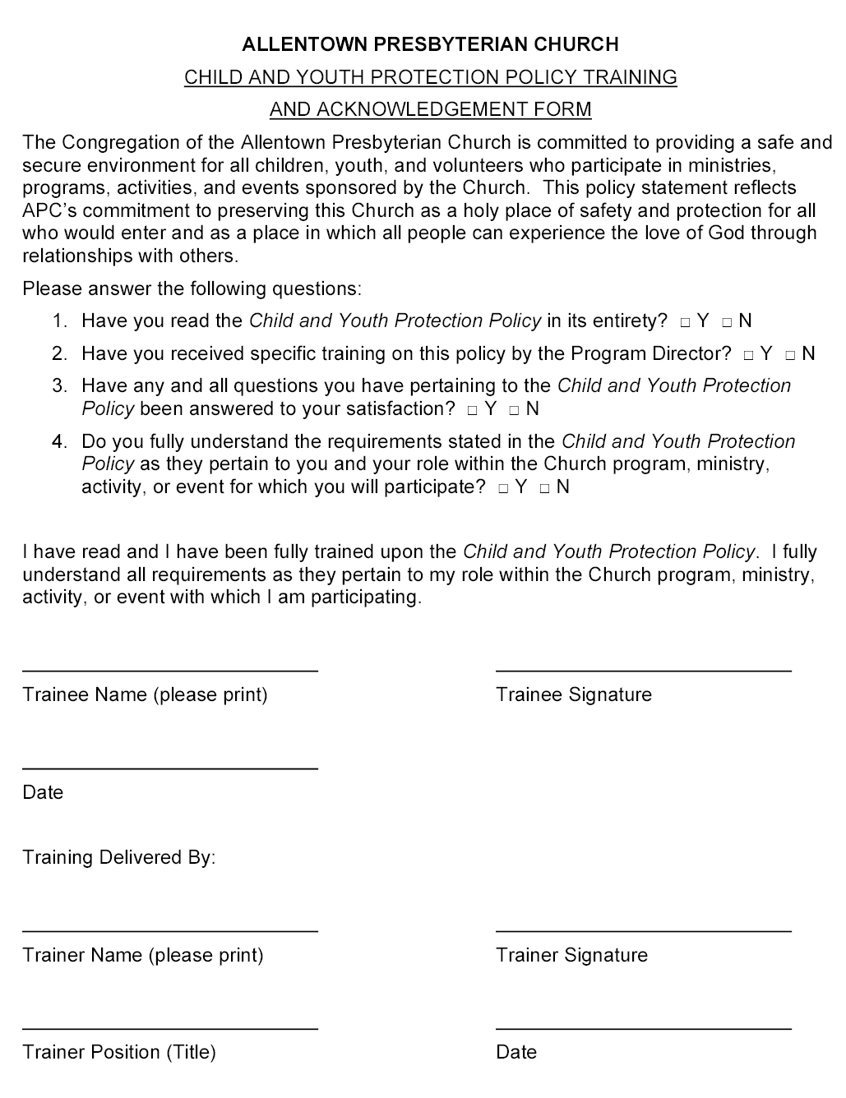

Attachment 2 – PARTICIPATION CONVENANT STATEMENT (EXAMPLE)

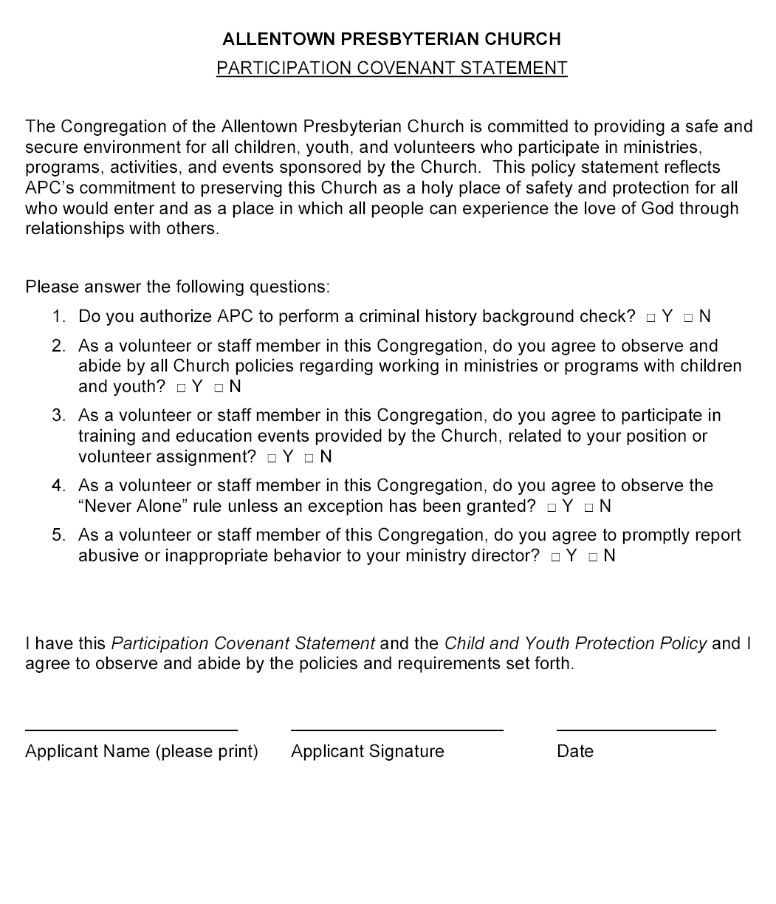

Attachment 3 – VOLUNTEER APPLICATION FORM (EXAMPLE – PAGE 1 of 2)
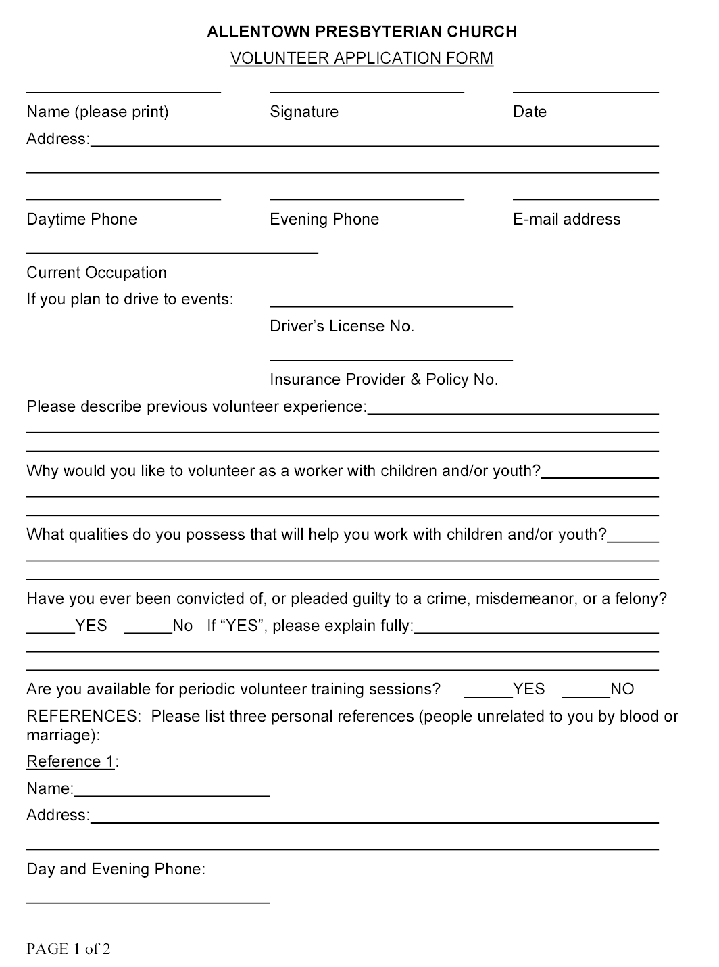
Attachment 3 (CONTINUED) – VOLUNTEER APPLICATION FORM (EXAMPLE – PAGE 2 of 2)
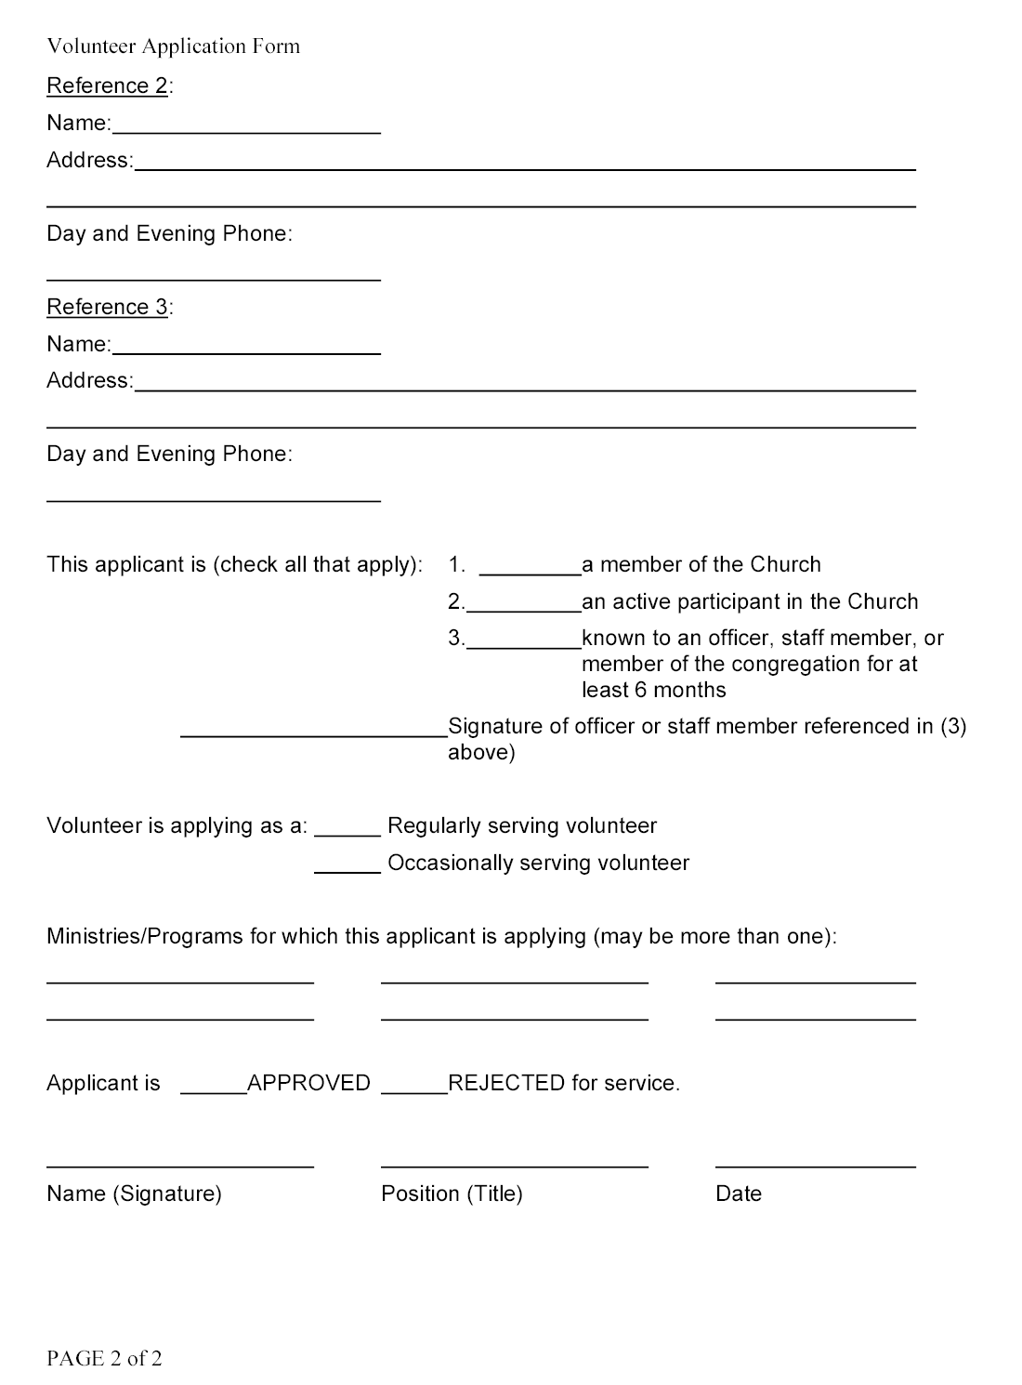

Attachment 4 – GUIDANCE FOR INTERACTING WITH CHILDREN OR YOUTH
This attachment is meant as guidance that will assist staff and RSVs in minimizing situations in which potential claims of abuse could occur or be claimed. The Church accepts that there may be, depending upon circumstances, exceptions to the guidance given below.
  - Avoid being on your own with any single child. This may mean groups working in one large room, or adjoining rooms.
  - Lay ground rules for all activities – no swearing, racism, calling each other names, respect for property, etc.
  - Never shout at or put down a child or youth.
  - Never take a child home on your own - preferably have another helper with you, or else ensure that the last two children are dropped off together.
  - Be wise in your physical contact with children.
  - Be wise with your relationship with the children - do not be over friendly with some at the expense of others. Don’t play “favorites.”.
  - Male helpers need to be particularly careful in what they say, and in being around forward young females. Female helpers similarly need to be careful with forward young male children.
  - Never strike, hit or physically discipline a child except by "holding" which may be used if there is an immediate danger of personal injury to the child or another person.
  - If you feel that a child may have a "crush" on you, inform the Program Director or your supervisor for advice and guidance.
  - Develop healthy relationships with children by listening to them and respecting them.
  - Be mindful of the safety of the children at all times, and in all circumstances.
  - Generally, have two adults present with a group, particularly when it is the only activity taking place on the church premises and do not take a group off the premises with fewer than two adults.
  - Where confidentiality is important (e.g. counseling a young person), ensure that others know that the interview is taking place and that someone else is around in the building.
  - In cases when discipline may be necessary, avoid disciplining in front of the group; talk to the child away from the group, but in a “public area.”.
  - Be aware that physical contact between adults and children can be quite healthy and is to be encouraged in public places, discouraged in circumstances where an adult/child are on their own.
  - Treat all children/young people with dignity and respect in attitude, language used and actions.
  - Respect the privacy of children; avoid questionable activity (e.g. rough/sexually provocative games or comments)
  - If you invite a child to your home, ensure another adult is present and the parent is aware
  - If transporting a child on their own, then it is better that the young person in the back seat.
  - It should be accepted that anyone seeing another worker acting in a way which could be misinterpreted should be able to speak to the individual or their supervisor about the concern.
  - Regular worker's to review procedures to ensure common approach, sharing concerns and identifying other matters which may need clarification and guidance.
  - Encourage feedback to program directors, Church leadership or to Session when departure from policy becomes necessary - this provides protection to the individual and draws the leadership's attention to shortcomings and problem areas.
  - Keep brief records of issues/decisions discussed at staff meetings.
Attachment 5 – ACTIVITY PERMISSION SLIP (EXAMPLE)
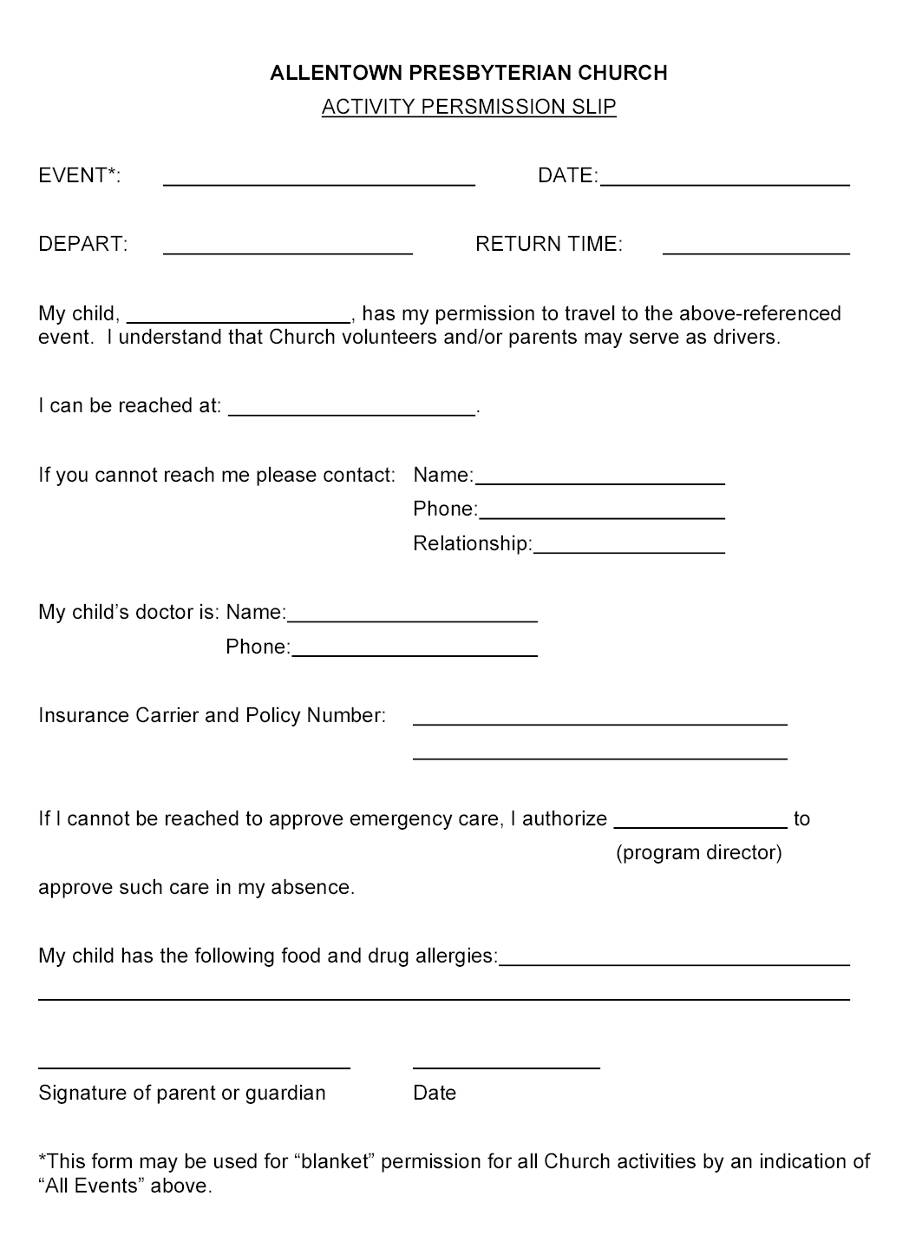

Attachment 6 – RELEASE FOR PUBLICATION FORM (EXAMPLE)

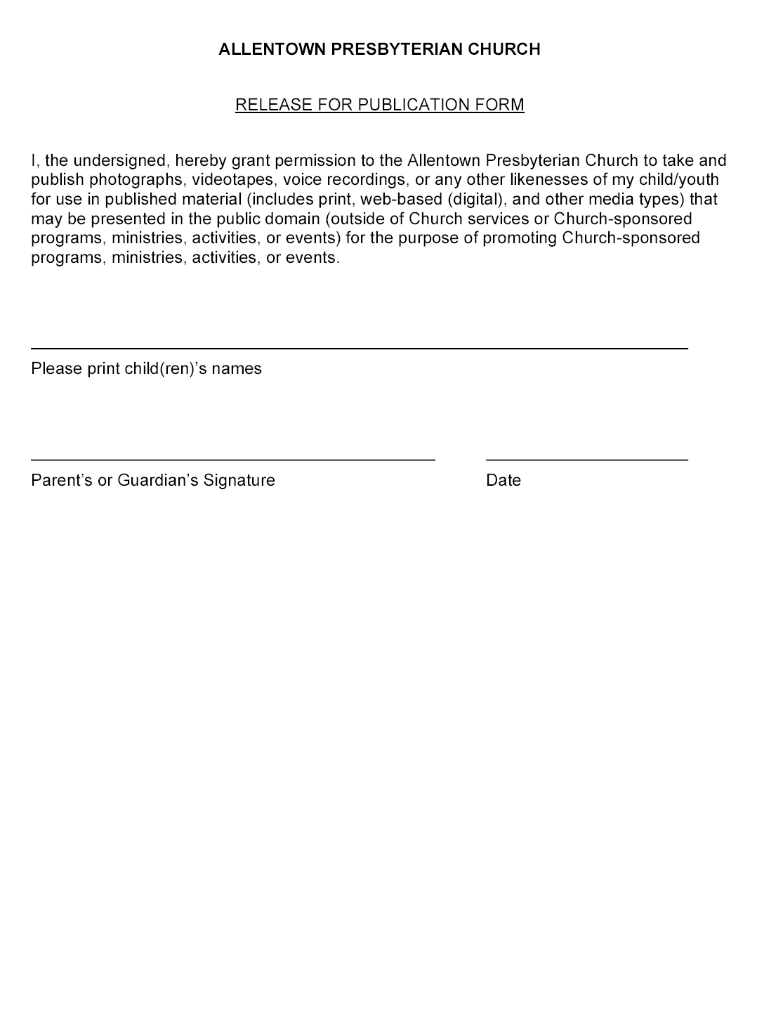

Attachment 7 – GUIDANCE FOR HANDLING ALLEGATIONS OF ABUSE FROM A CHILD OR YOUTH
Children's workers are in a unique position and your relationship with children cannot be underestimated. Your group may be providing a safe haven, and perhaps the only place where a child feels comfortable and able to talk to adults. It is therefore possible that a child may approach you to talk about abuse.

General points to consider
  - Accept what the child says.
  - Keep calm, do not appear to be shocked.
  - Look at the child directly.
  - Be honest.
  - Let them know that you will need to tell someone else - don't promise confidentiality.
  - Even when a child has broken a rule they are not to blame for the abuse.
  - Be aware the child may have been threatened.
  - Make notes as soon as possible, writing down exactly what the child said, including the child's name, age, address, relevant family information, and details of the situation and the activity that preceded disclosure.
  - Never push for information or question the child. Some helpful things to say might include:
      - “I believe you.”
      - “I am glad you have told me.”
      - “It's not your fault.”
      - “I will try to help you.”

Avoid saying:
      - “Why didn't you tell anyone before?”
      - “I can't believe it.”
      - “Are you sure this is true.”
      - “Why? How? When? Who? Where?”
      - "I'm shocked, don't tell anyone else."
  - Never make false promises.
  - Reassure the child they were right to tell you and that you believe them.
  - Let the child know what you are going to do next, and that you will let them know what happens.
  - Immediately inform the program director or your supervisor.
Note: Even if abuse is no longer happening, it is still important to report the matter, as the adult may be abusing other children. Also it may be that the child will need guidance and help in overcoming the effects of the abuse, plus the police may wish to prosecute.
Attachment 8 – PROCESS DIAGRAM FOR HANDLING KNOWN OR SUSPECTED INCIDENTS OF ABUSE
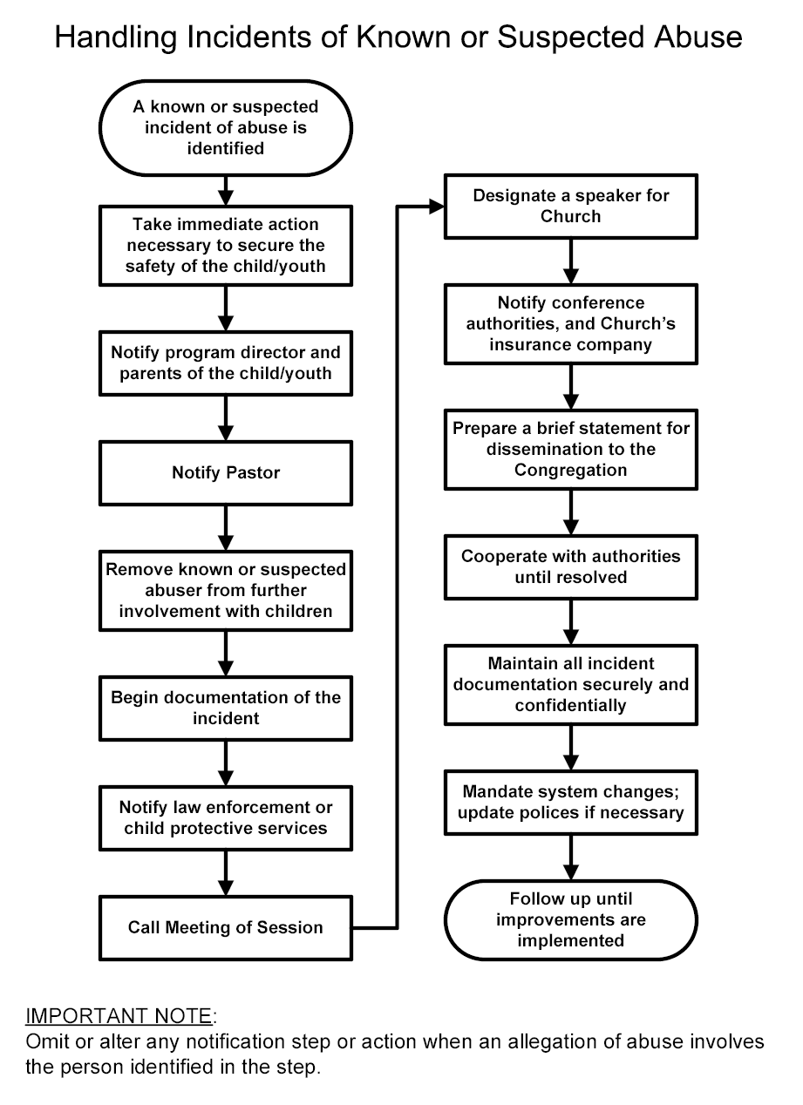

Attachment 9 – INCIDENT REPORT FORM (EXAMPLE)
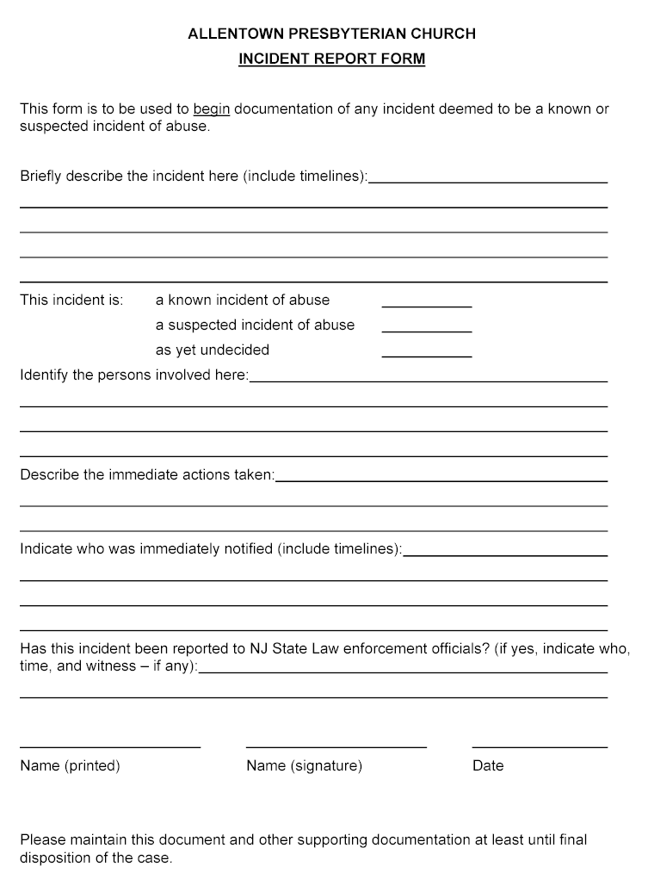

To avoid conflicts of interest, relatives of officers, staff members, or Program Directors applying as an RSV cannot name the officer, staff member, or Program Director to whom they are related as a reference on the Volunteer Application Form.
The view of the Church is that a child is never truly capable of consenting to or resisting such contact and/or sexual acts.
Modified from Safe Sanctuaries – Reducing the Risk of Child Abuse in the Church, by Joy T. Melton
Modified from Safe Sanctuaries – Reducing the Risk of Child Abuse in the Church, by Joy T. Melton

