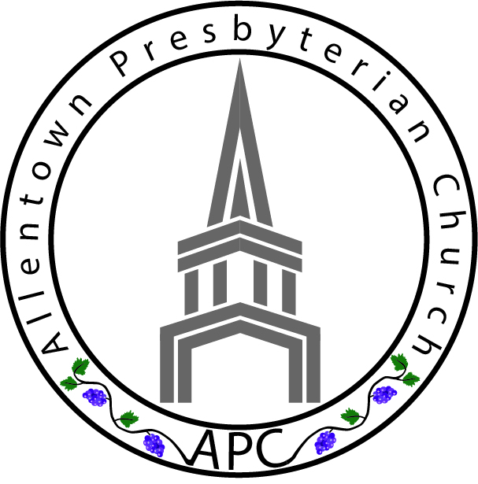
APC Confirmation Class Registration Form 2018-2019

STUDENT INFORMATION:
___________________________________________________ ________________
Student’s Full Name (for the Confirmation Certificate and Session Records) Date of Birth

_____________________________________________________________ ________________
Student’s Email Student’s Cell Phone #

Has this student been baptized? ❑ Yes ❑ No If yes,
___________________________________ ________________
Name of Church Date (approximate)

So that we can best serve your child, is there anything you want to share about your child? Please list any known conditions that we should be made aware of (i.e. Learning Disabilities, Allergies, Dietary Restrictions, Medications taken, Medical, Physical, Emotional, Behavioral, etc.)
__________________________________________________________________________________________________________________________________________________________________________________________________________________
______________________________________________________________________

PARENT INFORMATION:
___________________________________ ________________
Name (Parent #1) Cell Phone #

___________________________________ ________________
Home Address Email Address

___________________________________
City, State Zip

___________________________________ ________________
Name (Parent #2) Cell Phone #

___________________________________ ________________
Home Address (if different) Email Address

___________________________________
City, State Zip

Permission Information:
___________________________________ ________________
My child’s primary doctor Phone­­­­­­

___________________________________ ________________
Health Insurance Company Policy #
- My child (listed above) has permission to participate in all activities on the Allentown Presbyterian Church campus, including off-campus events, such a mission nights, special events and retreats. I understand my child will be traveling, either by foot or vehicle, with a church-approved Shepherd.

- I grant permission to the Allentown Presbyterian Church to take and publish photographs, video, voice recordings, or any other likeness of my child for use in materials, both print and digital, that may be presented in the public domain for the purpose of promoting APC’s programs and ministries.

- In the event of a medical emergency, I understand that I will be contacted immediately to authorize care. If I cannot be reached, I authorize Crossroads Youth & Young Adult Ministry staff to approve care.

________________________________________ _________________
Parent / Guardian Signature Date

Please complete and return this form to Karen Collins on 9/9/18

